**bioSite Q&A**

Who are you? (Introduce yourself in one or two sentences)

Hello, my name is Monica Anderson. I am a mom, wife, daughter, sister, and occupational therapist. These words come to mind when I am asked who I am because family is everything to me.

Where are you from? (Do you want to include your hometown, state, or country?)

I am from Modesto, California, born and raised.

What are you currently doing? (School, work, career path, or projects)

I have been working as an occupational therapist at an inpatient acute rehabilitation facility for almost four years now.

• What motivated you to pursue your field or studies?

Back in 2008, my grandmother had a stroke. It wasn’t until my grandmother had an occupational therapist, helping her recover, that I truly saw the meaning of what this field entailed. I found myself eager to learn more about the profession and fell in love with it, knowing that if I pursued this as my future career, I would be able to help those with their recovery through the incorporation of meaningful tasks.

What are your biggest strengths or skills?

My biggest strength is that I consider myself to be a considerate and compassionate person who thinks of others before I think of myself.

What do you value the most in your personal or professional life?

The thing that I value most in my personal life is time. Time is being spent with my family, those whom I love, and watching my child go through the different stages of all his milestones.

What are some accomplishments you’re proud of?

One of my biggest accomplishments is pursuing my doctorate degree and partaking in a rigorous program. I achieved that goal, and although it was hard, it was a fulfilling accomplishment in my life.

• What inspires or motivates you every day?

One of the things that inspires me the most is my two-year-old son. Every morning, he comes into my room with a big smile on his face, eager to take on the day.

What are your short-term goals (this year)?

My short-term goals this year are to complete a certification in my line of work. To continue to pursue my education and expand my knowledge of competencies. My other short-term goal is to continue to renovate our house so that we may expand our family.

What are your long-term goals (next 5–10 years)?

My long-term goals are to have my house paid off and create an exercise group within the community tailored to individuals living with Parkinson’s to bring more awareness to the effectiveness and importance of therapy.

What hobbies or activities do you enjoy the most?

I enjoy playing soccer with my little one, traveling, and exploring new places around the world while trying new foods according to what the culture has to offer.

How did you first get interested in them?

I began playing soccer when I was four years old until college. My two year old loves spending time outdoors and before we knew it we were playing sports for fun. When I met my husband, I mentioned how eager I was to be able to visit different locations on my bucket list around the world. I believe I got interested in traveling because I’ve always had an appreciation for culture and diversity. Since my husband and I have been married for three years, we have made it a tradition to take a week long trip at the minimum every year.

What do you like about each hobby (relaxing, creative, competitive, social, etc.)?

As someone who plays soccer as a hobby, the thing that I enjoy the most about it is that I get to incorporate my family into one of the hobbies that I’ve participated in for most of my life. I enjoy the relaxing and social aspect of traveling the most. I feel most at ease when we are traveling knowing that I get to experience it with those that I love. Often at times, my husband and I find ourselves meeting new people around the world that become long distance friends.

Do you do them alone or with friends/family?

I enjoy partaking in my hobbies with my family and friends.

What skills have your hobbies taught you (patience, teamwork, problem-solving)?

My hobbies have taught me to be able to dual task and problem solve. Soccer is a skill that requires quick thinking and reasoning in order to win a game. It also teaches you teamwork being able to communicate with others to hit an overarching goal. Traveling has taught me to be patient. Airport traffic, delayed flights, and loading has taught me that often at times things in our life happen that are out of our control and we have to be flexible and readjust.

Have any of your hobbies influenced your career/school goals?

When I made the decision to select what I wanted to pursue as my future career, traveling influenced me in ensuring that I would be able to find a job that was universal where jobs could be found around the world should I chose to move.

Do you have a favorite memory related to one of your hobbies?

One of my favorite memories about my hobby was being able to go to games on weekends where my whole family would gather to cheer me on. After every game, we would go out to lunch. To this day this a core memory of mine.

If you had unlimited time, what hobby would you spend the most time on?

If I had unlimited time and no paid time off to worry about, I would spend most of my time traveling with my family. I would visit all the spots on my bucket list including Japan and spend weeks out there studying the culture.

Do you see any of your hobbies becoming a side business or career?

I don’t foresee any of my hobbies becoming a side business or career at this time. I had an opportunity to do a traveling job as an occupational therapist but around that time I found out that we were expecting and decided that I wanted to stay close to our families so that our son could grow up with his cousins nearby and have consistency.

What new hobbies would you like to try in the future?

In the near future, I would like to pick up running. Running has always been something that I feel would be beneficial to incorporate into my life as it can give me opportunities to be outside more often and build my cardiovascular endurance

**About me.**

Monica Anderson is a devoted mother, wife, daughter, sister, and occupational therapist, whose life is anchored in family and meaningful connections. Born and raised in Modesto, California, Monica has spent nearly four years working in an inpatient acute rehabilitation facility, helping patients recover through the integration of purposeful tasks. Her inspiration to pursue occupational therapy came in 2008 when her grandmother suffered a stroke; witnessing her grandmother’s occupational therapist sparked a passion for the field that continues to guide her career today.

A lifelong learner, Monica recently achieved a major milestone by completing her doctorate degree, an accomplishment she describes as both challenging and fulfilling. She values compassion and consideration above all, applying these qualities both professionally and personally. Her short-term goals include completing a professional certification, expanding her knowledge, and continuing home renovations to accommodate her growing family. Looking further ahead, she hopes to pay off her home and create a community exercise group tailored to individuals with Parkinson’s disease, promoting therapy and wellness.

Outside of work, Monica enjoys playing soccer, traveling, and exploring new cultures with her family. Soccer allows her to share a lifelong passion with her son, while traveling offers relaxation and social connection. These hobbies have also taught her teamwork, patience, and problem-solving—skills that enhance both her personal life and professional practice. In the future, she hopes to incorporate running into her routine to further improve her health and spend more active time outdoors. Monica’s life reflects a balance of dedication to family, professional growth, and personal enrichment.

**Chosen Palate**

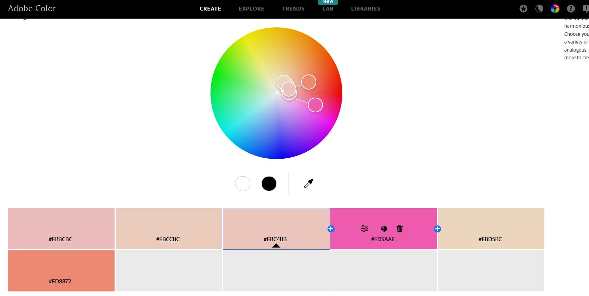

**bioSite brief prototype of website flow**

**HTML Foundation – Landing Page**

Images for Website

